**Informed Consent**

**Atropine Ophthalmic Solution**

You or your child have been diagnosed with myopia (nearsightedness), a condition causing blurry distance vision. Myopia may increase the risk of several sight-threatening diseases such as myopic macular degeneration, cataracts, glaucoma, retinal holes and retinal detachments during adulthood.

We are recommending the use of Atropine eye drops (Atropine) as a treatment option for myopia.

Risks associated with Atropine include:

* temporary blurred near vision
* pupil dilation
* light sensitivity

Although rare, the most common side effects from Atropine are:

* mild burning or stinging upon instillation
* minor light sensitivity
* minor problems focusing on things up close.

To help ensure the best possible outcome, it is critical that you keep all scheduled appointments and alert our office immediately if you or your child is experiencing any side effects from the drops. These side effects are very rare and if they do occur, they do so in varying degrees with different patients. Stopping the use of the drops usually eliminates the side effects. Should you or your child experience any side effects from the drops, you should contact our office immediately and discontinue further use until you speak to a doctor.

Office visits during the first year of treatment will be scheduled as follows:

* 1 week
* 1 month
* 3 month
* 6 months

Depending on the rate of myopic progression, additional visits may be required and will be determined by the provider on a case by case basis.

After the first year, an annual examination and Atropine evaluation is required to ensure ongoing optimal visual health and the stability of the therapeutic effect. Three to six-month monitoring visits will be scheduled on an ongoing basis as required.

Although Atropine has been approved by the FDA, the FDA has not specifically approved its use for slowing the progression of myopia. However, Atropine has been shown to be effective in slowing the progression of myopia. The use of a medication for purposes for which it is not intended is a common practice in medicine and is referred to as “off label” use. 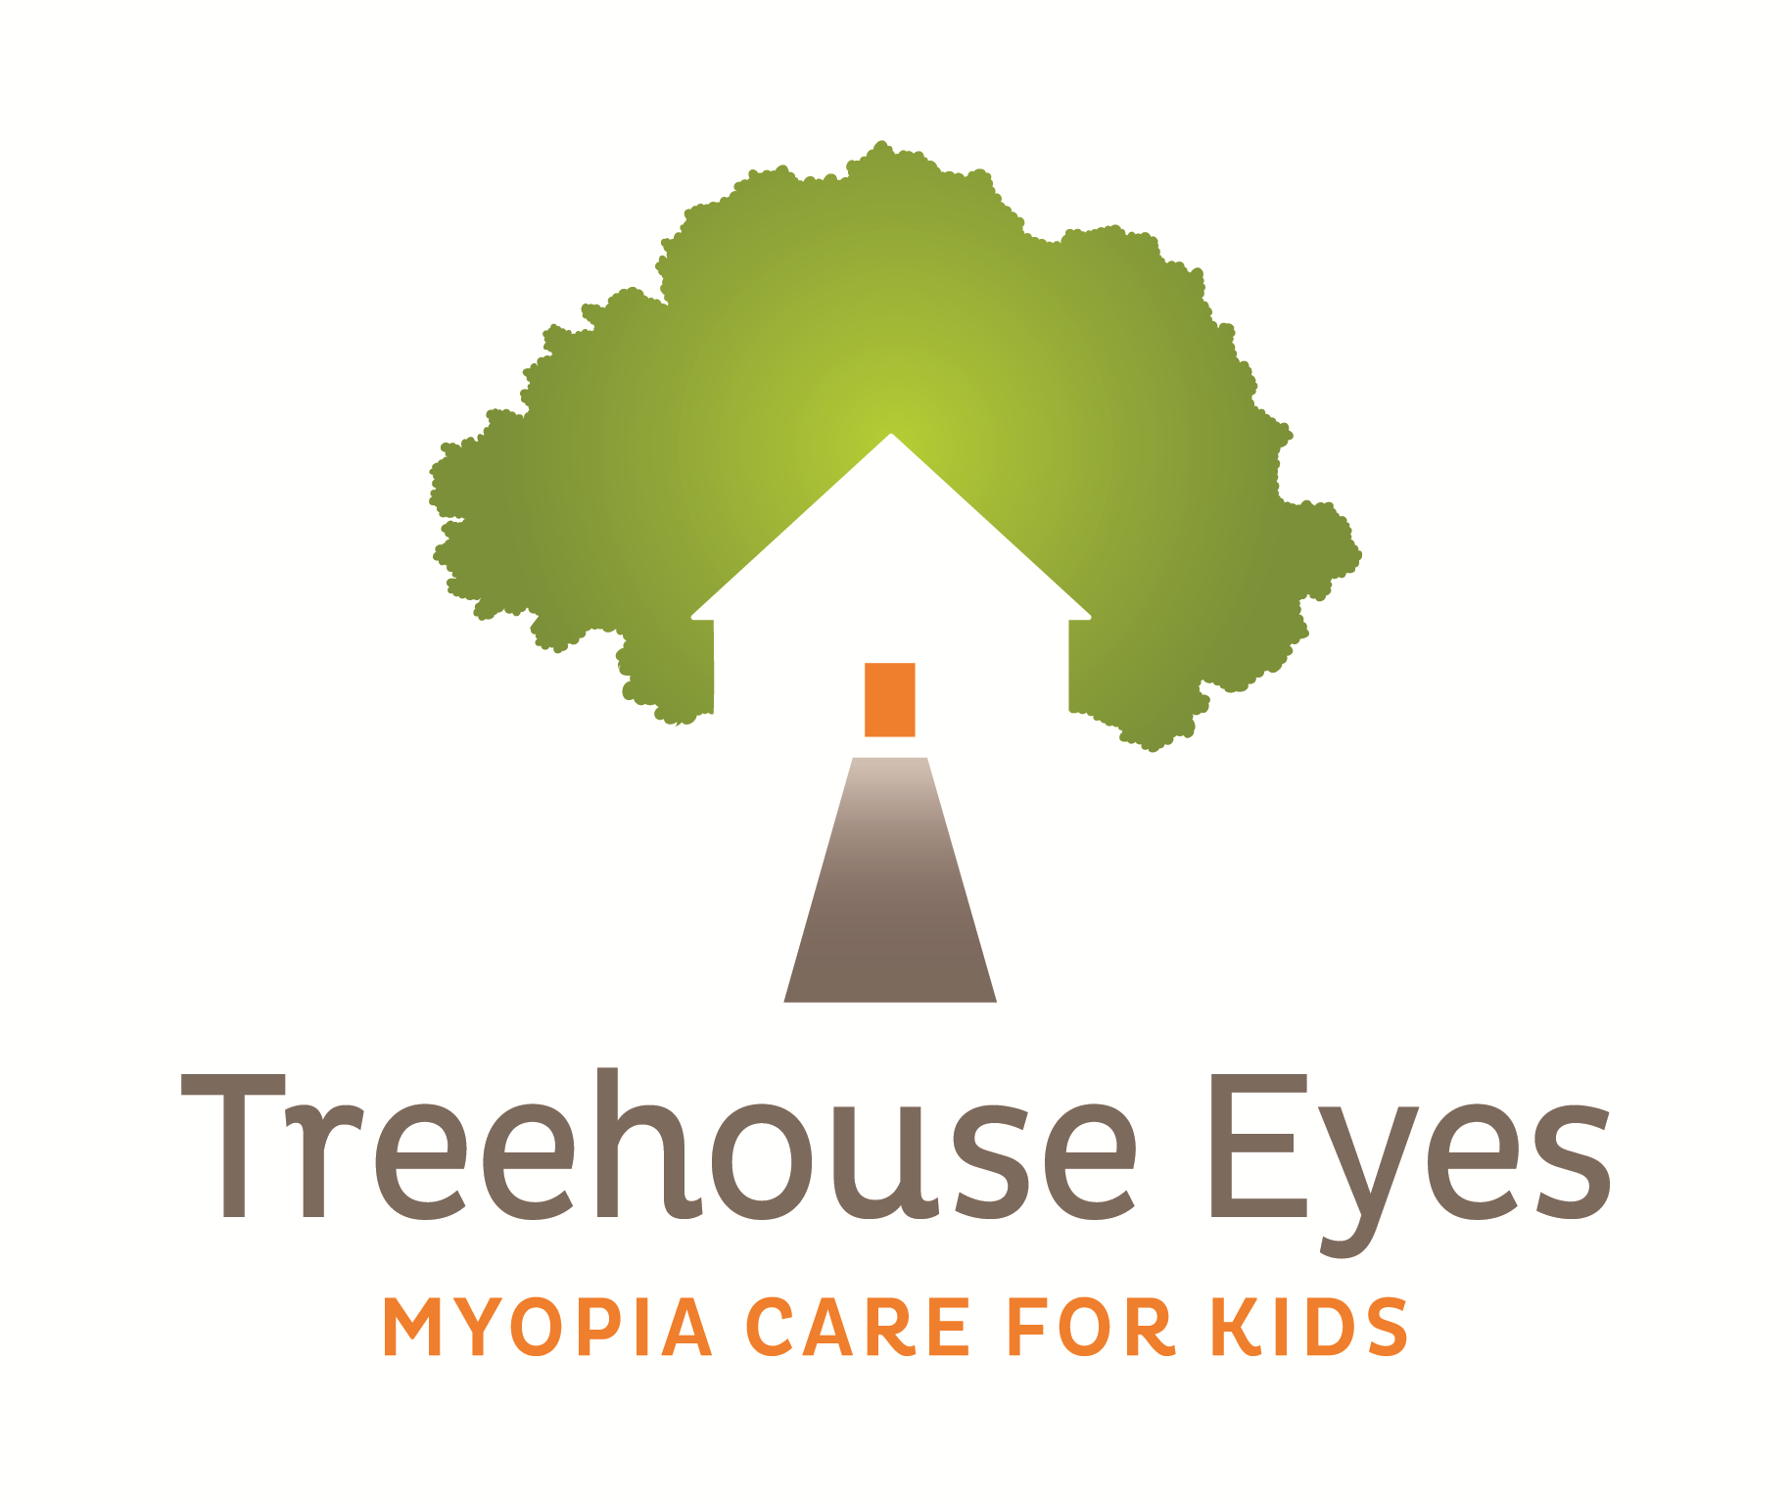

There are alternative treatments available that may slow the rate of the progression of myopia. These include corneal reshaping contact lenses and custom designed soft contact lenses. Each of these has its own unique advantages, disadvantages, risks, and benefits. While conventional glasses or contact lenses correct the blurred vision from myopia, their use has not been shown to effectively slow myopic progression.

I, _________________________________, agree to be treated/have my child treated with Atropine Ophthalmic Solution for the treatment of pediatric myopia and I acknowledge the following:

* + - I have been informed of the purpose, risks, and benefits of treatment with Atropine and have been informed of other treatment options.
* All of my questions have been addressed and answered to my satisfaction and understanding.
* Not attempting to slow down the progression of myopia may also carry with it certain risks, including permanent vision loss, particularly later in life and in higher degrees of myopia.
* The use of Atropine eye drops is being used as an “off label” use.
* No guarantee or assurance has been given by anyone as to the specific results that may be obtained by using Atropine eye drops.
* I agree to follow the treatment regimen required for Atropine.
* I will contact the office immediately in the event of the presence of any of the side effects listed above or in the case of an emergency.
* I will keep all scheduled appointments, as per the protocol.

My signature below confirms my understanding of the requirements for treatment with Atropine. I further understand that failure to comply with the requirements may lead to termination from the treatment program.

__________________________________ _____ / _____ / _____

Patient/Guardian Signature Date

__________________________________ _____ / _____ / _____

Doctor Signature Date